***Data Visualization (DSC 465)***

***Group Project***

***Group 4 (Data Allies)***

**Introduction**

The Second World War, spanned from 1939 to 1945, was a global conflict that involved most of the world's nations, including all the great powers, eventually forming two opposing military alliances: the Allies and the Axis. It was the most widespread war in history, and it directly involved more than 100 million people from over 30 countries. In a state of total war, the major participants threw their entire economic, industrial, and scientific capabilities behind the war effort, erasing the distinction between civilian and military resources. This dataset provides a detailed compilation of aerial operations conducted during this monumental conflict by the allied forces, offering insights into the strategic decisions that shaped the course of history.

The data collected in this dataset comes from a variety of carefully curated sources. It encompasses records of aerial missions carried out by Allied forces consisting of the United States, Great Britan and Joint forces across different theaters of war, namely the European Theater of Operations (ETO), the Pacific Theater of Operations (PTO) and

**Data Source** – (https://data.world/datamil/world-war-ii-thor-data)

**Data Shape:**

* Dataset Shape – 178,281 Rows, 56 Columns
* Number of Categorical Columns – 19
* Number of Numerical Columns – 29
* Location Data – 6 Columns have location data in terms of latitude and longitude.
* Timeseries Data – 2 Columns

Key Variables in the Dataset

* WWII_ID: A unique identifier for each recorded operation, ensuring the traceability and distinct analysis of each mission.
* MSNDATE: The exact date of the mission, which helps in analyzing the chronological order and timing of military strategies.
* THEATER: Identifies the theater of operations, which distinguishes between different strategic areas such as the Mediterranean (MTO), European (ETO), and Pacific (PTO).
* COUNTRY_FLYING_MISSION: The country responsible for the mission, which is crucial for understanding the involvement of different nations over the course of the war.
* TGT_COUNTRY and TGT_LOCATION: These fields record the target nation and specific locations, providing insights into the strategic focus of aerial operations.
* TGT_TYPE: The type of target engaged, which helps in analyzing the tactical objectives of air raids, whether against industrial centers, military installations, or civilian areas.
* AIRCRAFT_NAME: Indicates the type of aircraft used, offering a perspective on the technological and tactical evolution of air forces during the war.
* TONS_OF_BOMBS: The weight of bombs dropped during the mission, a critical measure of the scale and intensity of bombing operations.

In this project we aim to visualize and analyze these aspects to understand better the dynamics and impact of aerial warfare in World War II. Through detailed exploratory analysis and carefully designed visualizations, we will uncover the patterns and trends that define this significant historical period, providing a narrative that complements historical accounts with quantitative data analysis.

**Exploratory Analysis:**

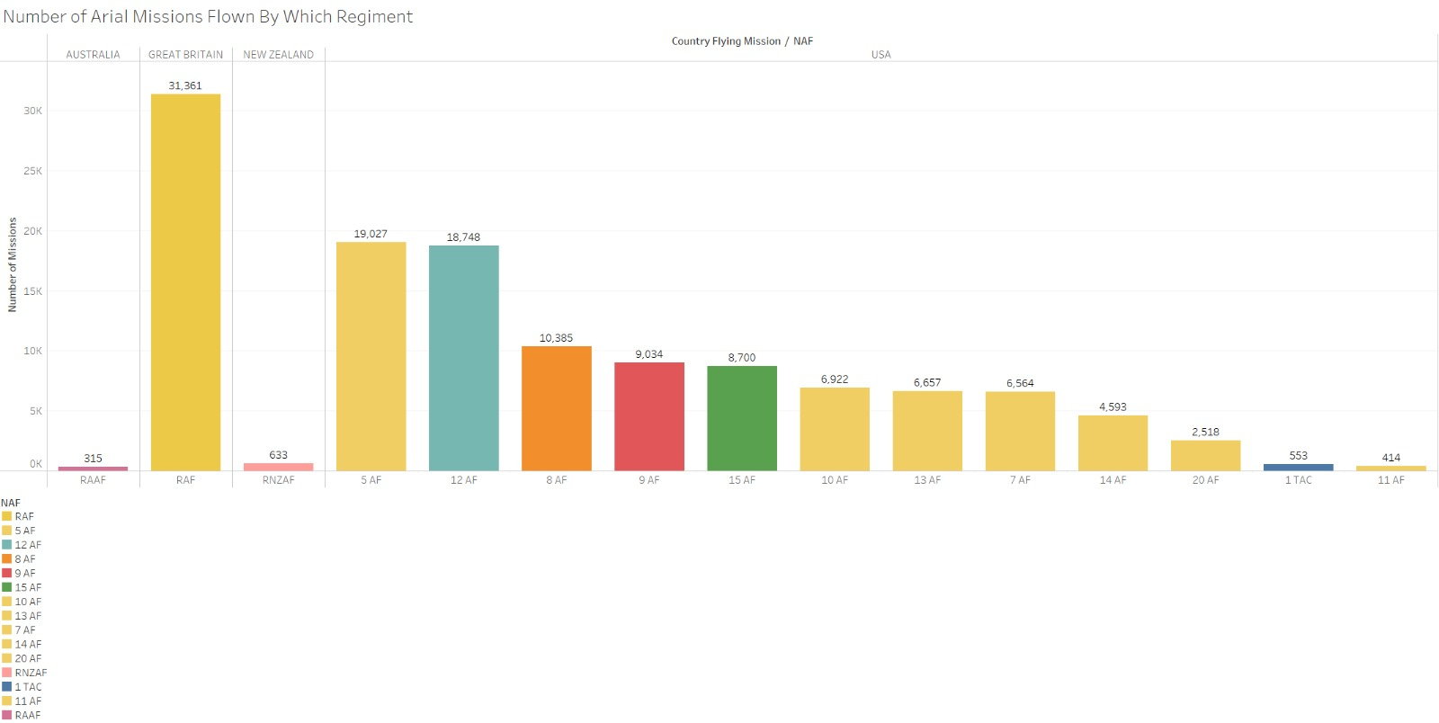

**Fig.1:** Number of Arial Missions Flown by which Regiment.

The bar chart in Fig.1 illustrates the number of aerial missions flown by different air force regiments during World War II, focusing on the contributions from Australia, New Zealand, and the USA. The regiments are identified by their abbreviations such as RAAF (Royal Australian Air Force), RAF (Royal Air Force), and various American Air Force units distinguished by numbers (e.g., 5 AF for Fifth Air Force). This chart effectively displays the scale of involvement and the operational scope of each air force regiment in the Allied war effort.

From the chart, it's clear that the Royal Air Force (RAF flew the highest number of missions among the displayed regiments with over 31,000 missions, emphasizing United Kingdom’s significant contribution to the air war. The American regiments, displayed in multiple shades, show a range of involvement with the 5th Air Force and 12th Air Force being particularly active. This visual representation helps to understand not only the breadth of participation by different national forces but also the varying levels of intensity in their operational theaters throughout the war.

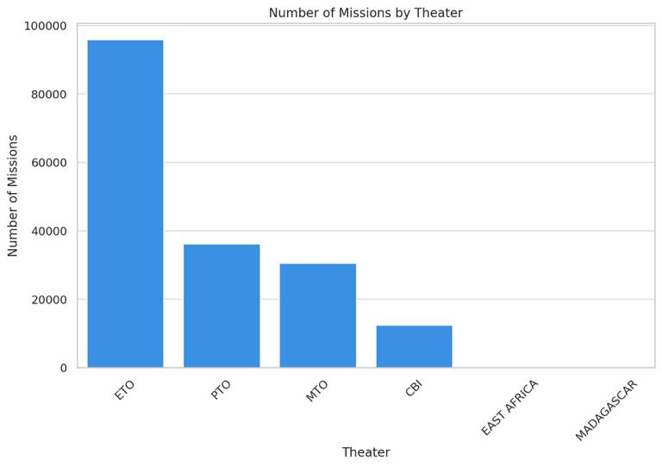

**Fig.2:** Number of missions by theater

This Fig.2 displays the number of missions conducted in each theater of operations. The European Theater (ETO) and Pacific Theater (PTO) show high activity, reflecting the intense aerial campaigns conducted in these regions. This visualization helps identify which theaters were the focal points of air operations during World War II.

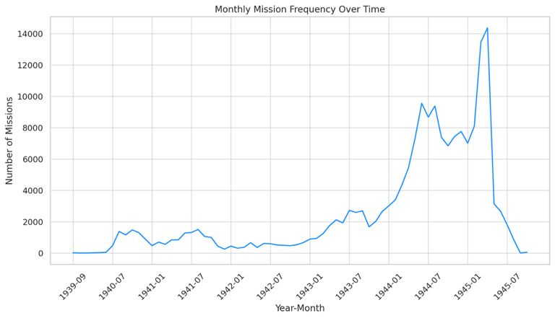

**Fig.3:** Monthly Mission Frequency Over WW2 time

The line graph in Fig.3 illustrates the frequency of mission’s month-by-month throughout World War II. There are visible peaks which likely correspond to significant military campaigns. This graph is useful for analyzing how aerial mission intensity varied with the progression of the war and major historical events.

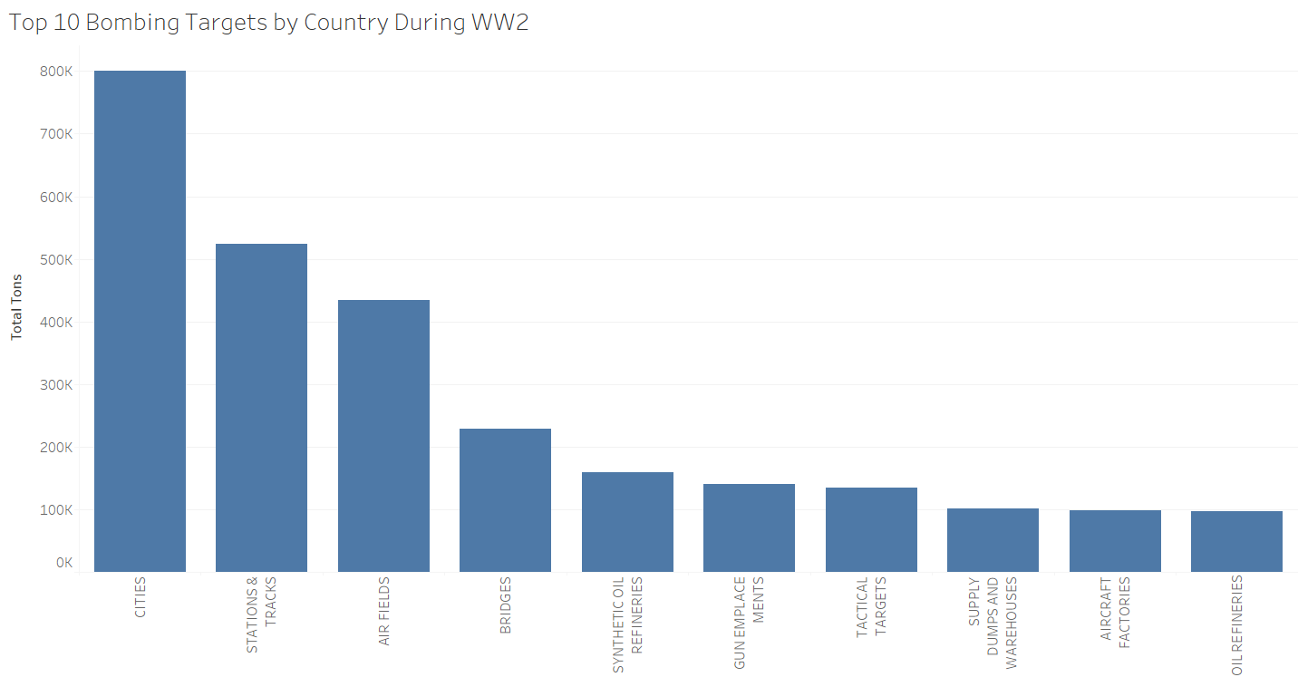

**Fig.4:** Top Targets by Type

This Fig.4 ranks the most common types of targets bombed during the war. Industrial and military targets are among the most frequent, highlighting strategic efforts to cripple enemy infrastructure and support capabilities. Understanding these priorities helps elucidate the strategic objectives behind the bombing campaigns.

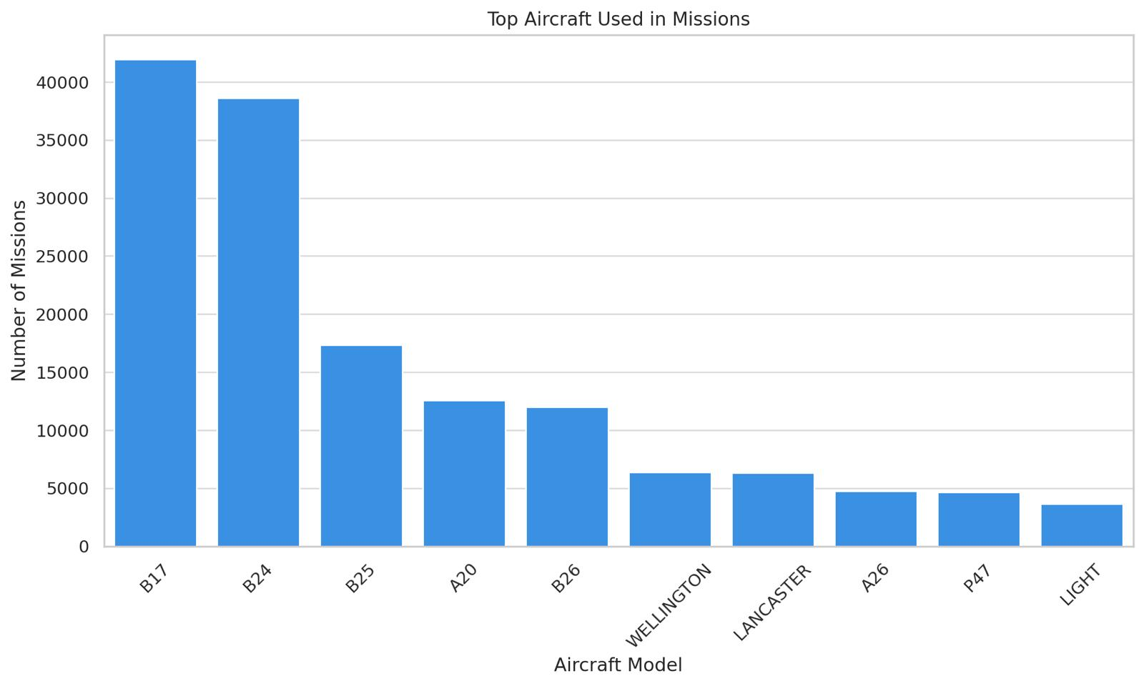  
**Fig.5:** Top Aircrafts used in Missions.

This graph in Fig.5 displays the most frequently used aircraft models in World War II missions, providing a glimpse into the technological diversity and preferences in aircraft selection. Each bar represents the number of missions in which a particular aircraft model was used, illustrating the workhorses of the air campaigns. This information can shed light on the strategic and operational decisions regarding aircraft deployment during the war.

**Visualizations:**

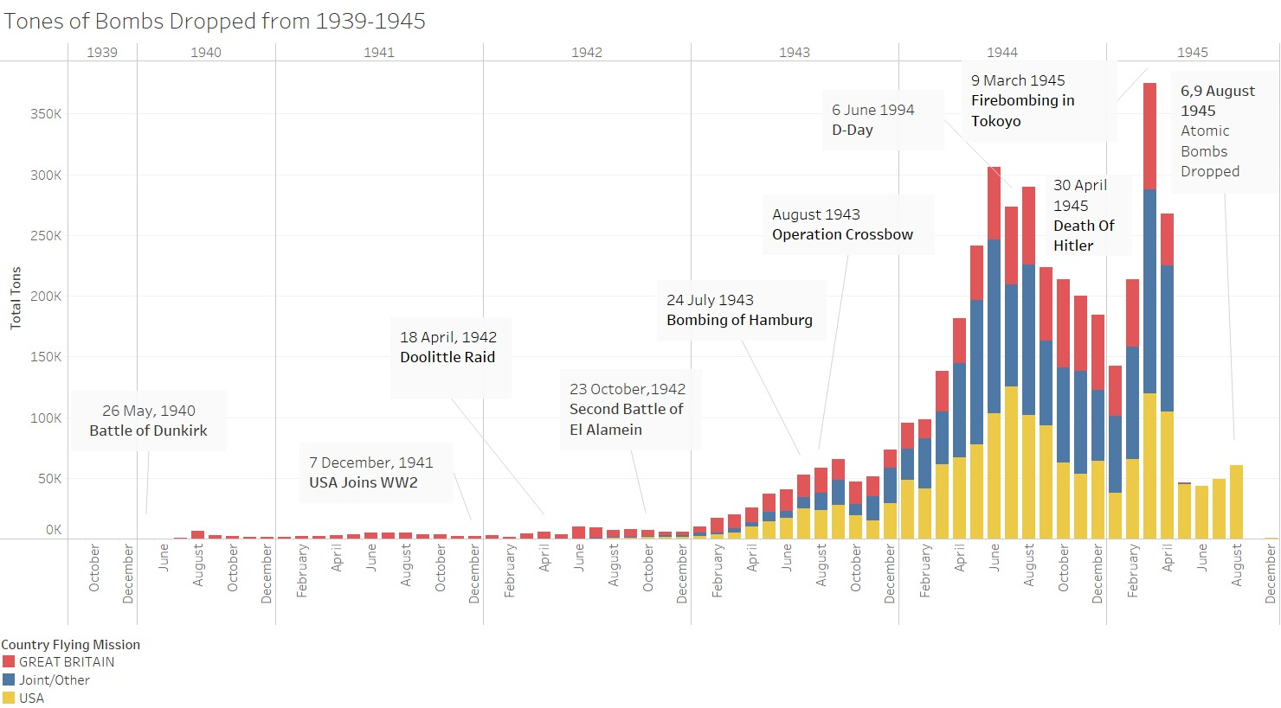

**Fig.6:** Tons of Bombs dropped from 1939-45.

The bar chart visualizes the total tonnage of bombs dropped by the Allied forces during World War II from 1939 to 1945, offering a quantitative insight into the aerial bombardment efforts throughout the conflict. The data is segmented by the countries conducting the missions—Great Britain, the USA, and joint or other Allied missions using color coding: red for Great Britain, yellow for the USA, and blue for Joint/Other. Significant historical events are annotated on the timeline to provide context to the fluctuations and peaks in bombing intensity, such as "D-Day," "The Bombing of Hamburg,", "Death of Hitler" and "Atomic Bombs Dropped."

From this visualization, we can deduce several key points about the Allied strategic bombing campaign. Initially, British forces dominated the efforts (as shown by the red bars) in the early years of the war, reflecting Britain's engagement before the USA's entry on December 7th 1941 following the attack on pearl harbor . Following this, there is a noticeable increase in the tonnage dropped, particularly from 1942 onwards, coinciding with the USA ramping up its military involvement in Europe. The chart peaks around significant event on 30th April 1945 making the end of the World War 2 in the European front following the death of Hitler. This chart reflects the scale of the Allied bombing campaigns and also helps to understand the shifting dynamics and intensification of the war effort over time.

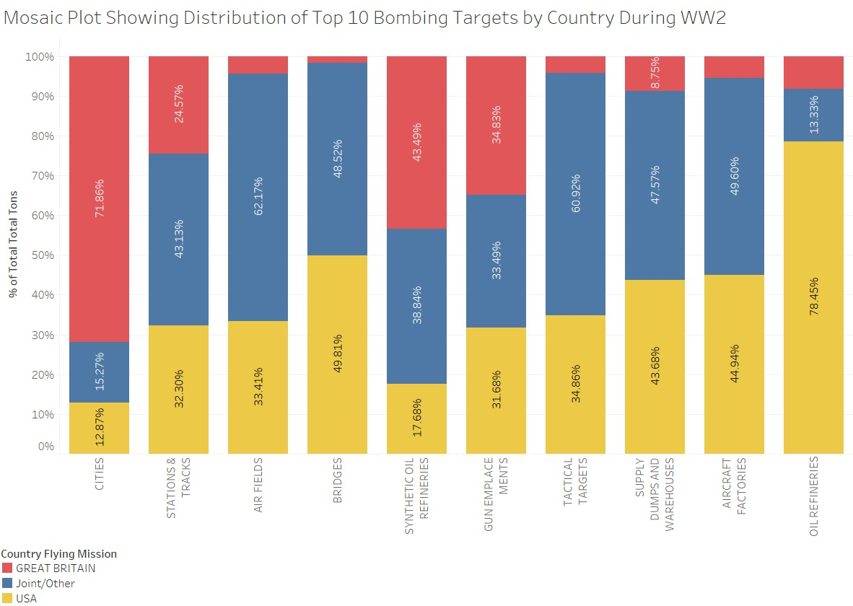

**Fig.7:** Top 10 Bombing targets by Country.

The mosaic plot in Fig.6 illustrates the distribution of the top 10 bombing targets by the Allied forces during World War II, segmented by the country conducting the missions—Great Britain, the USA, and joint or other Allied missions. Each category of target—such as cities, airfields, bridges, synthetic oil refineries, and others—is represented by a colored bar that indicates the percentage of total tonnage dropped on that specific type of target. Red bars represent Great Britain, blue bars for the USA, and yellow bars for joint or other missions. This visualization helps to quantify the focus of bombing efforts on different strategic objectives and how responsibilities and tactical preferences differed among the Allied powers.

From the chart, it is evident that different types of targets received varying degrees of attention depending on the strategic needs and capabilities of the forces involved. For instance, the high percentage of bombs dropped by the USA on synthetic oil refineries and aircraft factories—48.98% and 44.49% respectively—highlights their strategy to cripple German war production and supply lines. In contrast, Great Britain focused a significant portion of its efforts on bombing cities (71.68%), which aligns with their earlier and sustained area-bombing strategy aimed at undermining German morale and infrastructure. The chart reflects the strategic emphases of each country and also illustrates how the Allies allocated their aerial resources across different target types to achieve their overall war objectives.



**Fig.8:** Target Priority Expansion in Europe Region

This Fig.8 map visualizes the geographic distribution of WW 2 missions based on the target priority explanation across Europe. Each of the points present on the map represents a mission and the location of the target, the points are colored based on the target priority explanation (Tgt Priority Explanation). This target priority is divided into four main categories. Primary target represented by red color, secondary target by orange color, the target of last resort represented by blue color and target of opportunity represented by green. Such graphs are helpful in understanding the strategic decisions made during a war. This also highlights the force’s ability to be flexible when needed.

From the map, one can observe that the regions of high density are Germany, Italy, Belgium, France mainly for primary and secondary targets and Austria, Netherlands, Switzerland displaying comparatively fewer number of targets. Additionally, countries like Czechoslovakia, Poland, Greece, Hungary have target densities, but the primary targets are less in number. This signifies that the regions were not vital or that it was challenging to target due to the geographical factors. The high density of targets around cities such as Berlin, Munich and Hamburg provide us information that the enemy were targeting the industrial, transportation hubs and the military installation in Germany.

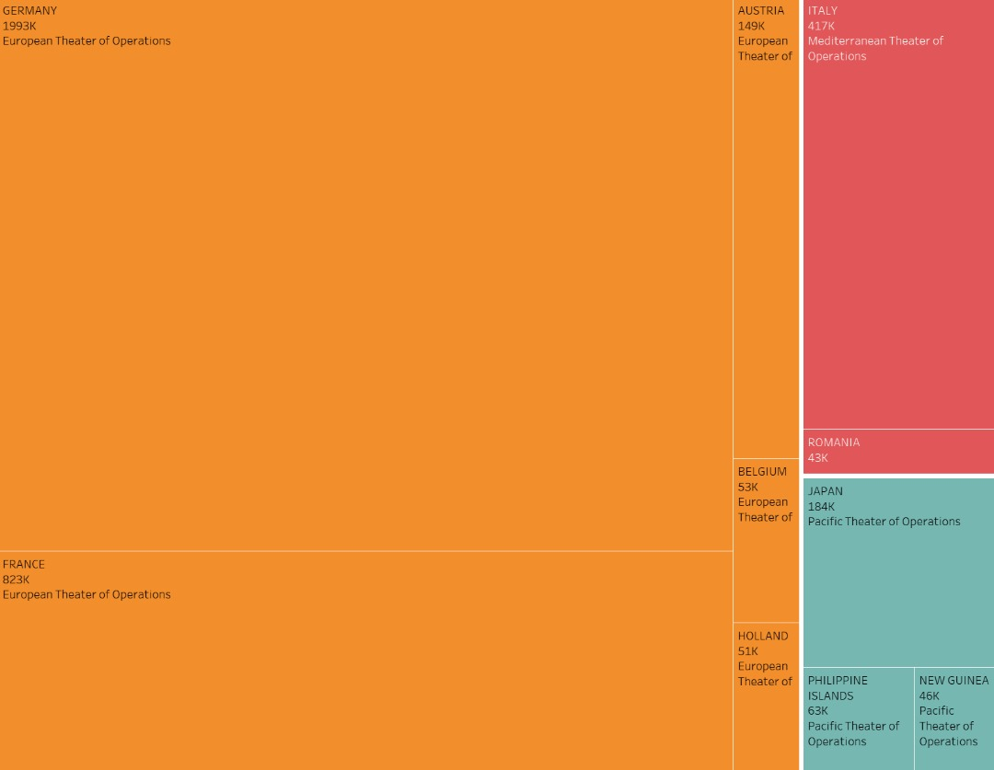

**Fig.9:** Tree Map of Top 10 most Bombed Countries.

This tree-map in Fig.9 depicts the top ten most bombarded countries and the severity of the airstrikes. Each rectangle in the tree map represents a target country, with total tons (Bombs) and hue indicating a specific theater of operations. Theater of operations in warfare represent an area in which military events occur or are in progress. The tree map consisted of three theaters of operations: Europe (orange), the Mediterranean (red), and the Pacific (teal), and it efficiently presented the top ten bombed countries in a hierarchical framework. The tree map was useful in understanding which countries were most affected by the conflict. The three most targeted countries were Germany, Italy, and Japan and they were under the control of the Axis Powers.

The tree-map shows that the three countries with the most bombings were Germany, France, and Italy. Germany was the world's most extensively bombed country throughout the war, with a total tonnage of 1,993,000. Italy, Belgium and Holland were also targeted but not as much as Germany, France and Italy. Furthermore, the European theater of operations (ETO) was hit the worst, followed by the Mediterranean theater of operations (MTO) and the Pacific theater of operations (PTO). Italy suffered the most attacks in the Mediterranean region. China-Burma-India (CBI) was the least attacked region throughout the war, with a total tonnage of 35,000.



**Fig.10:** Timeline graph of Bombing missions in Europe Region.

This map in Fig.10 visualizes the geographic region of Europe based on WWII Bombing Missions. The countries targeted are seen in a yellow-to-red color scale. Red are hotspots which mean that the area has been targeted frequently. Such graphs are helpful in visualizing the disastrous events that took place as the years progressed. One can only imagine the loss to civilians, armed forces, and destruction to cities.

As the timeline goes on, one can see that France, Italy, and Germany are one of the heavily targeted areas on the graph. We can come to the conclusion that these countries had huge involvement in the war, which is confirmed by the historical accuracy of this dataset.

**Conclusion:** In conclusion, this comprehensive analysis of World War II aerial operations has provided deep insights into the strategic military efforts that significantly influenced the war's outcome. Through a detailed examination of mission data, aircraft types, and bombing targets, we have gained a better understanding of how the Allies utilized their air power to target strategic sites across different theaters of war, contributing to the Allied victory. These visualizations enriched our historical knowledge and underscores the importance of strategic planning in wartime efforts, highlighting the crucial role of air force regiments from various nations in shaping the course of history.

***Individual Project Report (Atta Yaw Agyeman)***

The World War II. Theater History of Operations (THOR) dataset covers World War II. World War II (1939-1945) was a global conflict in which the majority of the world's nations, including all major powers, formed two opposing military alliances: the Allies and the Axis. The war began when Germany invaded Poland, prompting Britain and France to declare war on Germany. The Holocaust, Pearl Harbor, D-Day, and the Hiroshima and Nagasaki atomic bombings were among the most momentous events. It killed an estimated 70-85 million people, making it the worst war in history. The war ended with the Axis troops' unconditional surrender, which radically altered world political and social structures, precipitating the Cold War. We employed a variety of visuals to highlight major trends and patterns during the aerial bombing campaigns of WWII.

My efforts included coordinating my team members, particularly the optimum time to meet, and informing them about when and where to meet for the project. I assisted in putting the slides together. We met once a week, usually on Fridays, and worked on the project in a systematic manner.

The World War II THOR dataset contained 178,281 rows and 56 columns. There were 19 categorical variables and 29 numerical variables.

I recommended showing a tree-map visualization where I used the following variables Target country, theater of operations, and total tons of bombings to identify the top ten countries that have been heavily targeted by missiles. I eliminated null values and recalculated fields like theater to create a more efficient representation. Furthermore, I suggested that we utilize a geo map to depict the various countries affected by the bombs, as this would highlight all countries that were hit as well as those that were damaged minimally.

I also contributed to the final production of the report by writing a portion of it and helping to develop the presentation slides. At the end of the graphics, it was clear that Germany was the most targeted country, receiving the most bombardment totaling 1,993,000 tons, more than twice France's 823,000 tons in the European theater of operations. Japan, a German ally, was the most heavily bombed country in the Pacific region, receiving 184,000 tons. It was unsurprising that Germany had to surrender at the end of WWII. The Axis Powers, which included Germany and Japan, lost the war, as shown by the visuals.

The project taught me the value of data and how to use it effectively to create visualizations in data science. One takeaway for me from this project is how to visually communicate a story with a given dataset. The use of color aided in the analysis and comprehension of the complex dataset, and I learned how important it is to use clean data. I improved my data visualization skills by using the Tableau visualization tool for this project.

***Individual Report (Sarah Hashmi)***

During the tenure of our group project, I believe I played the role of a supportive team member well. I made sure ideas were being listened to, I participated regularly in discussions, and I took on tasks that were challenging. I even took responsibility of making sure group members submitted key documents on time and in moments which they didn’t I stepped up for the role. Overall, our group members had each other’s backs and made sure to help each other so there wasn’t a lot on our plates.

One such challenging task that I took on was creating a geographic regional map visualization that corresponds to European country bombings during World War II. The basic idea was that there would be a slider that would show changes on the graph as the time went by. To do so, I worked with the cleaned dataset from our data preprocessing step. Then, I loaded the dataset into tableau where I began creating the map base. I moved longitude to the columns shelf and latitude to the rows shelf. Then, I moved mission date to the pages shelf and re-ordered the dates to be read by month first. Finally, I moved target country to the color and detail boxes in the “marks” shelves. I chose a color scheme that would emphasize frequently bombed areas or “hotspots” using a light to dark color scheme like yellow to red. Voila, here my European regional map came to life. Finally, to create the GIF, I screen recorded the video, cut, and cropped the video, rendered the video to fit a full screen, and exported it as a GIF.

This first-hand experience working with a geographic visualization of my own choice taught me more about things to pay attention to when it comes to creating a map. I didn’t realize how important specific date values would be and how important color scheme especially on a map and to the type of story is. I don’t think I noticed these things on the first couple of homework assignments where we worked similarly with these types of maps.

***Individual Report (Harigovind Rajagopal)***

In this project of analyzing and visualizing the WW II dataset, we acknowledged at each instance about the amount of suffering that occurred during this world war.

In the process of analyzing the dataset, I had to look into various factors, upon which I came across missions’ distribution pattern. Although might seem unnecessary, it does play a very important role in analyzing the planned targets and its resultant. Each of these missions' targets display the felicity and adaptability of the force. The significance of target of opportunity present across the map, implies this opportunistic approach by the allies. The target of last resort suggests these were targeted when the primary targets were unable to be reached.

With the help of tableau, I was able to develop a map visualization which plotted various missions conducted across Europe. Countries such as Germany, Belgium, France, Austria, Netherlands, Poland, Switzerland, Hungary were primarily involved. A single point in the map represents a mission and this mission is categorized into four categories based on the priority. Primary target (red), Secondary target (Orange), Target of last resort (Blue), Target of opportunity (Green). These categories signifies the pattern and importance of targeting the part like the high density of missions particularly in Germany, Italy, France and Belgium demonstrate that these areas were either of strategic importance or considerable activity of military and the highest density in Germany indicates the role played by the country in the war.

This project played a vital role in understanding the importance and usage of data visualization in computer science, where data plays a significant role. I understood the importance of effective and clear data representation. As explained by the professor, Data Audience message plays a vital role in data visualization. Making use of the color codes in the map helped in understanding the complex data and analyzing the dataset. In addition to this, I also learnt the necessity of carefully considering and cleaning the data, as the data consists of information of historical presence. I understood the practical importance of visual storytelling while working on this project.

The map, which was very informative of the data points, also provided insights into the tactics and strategy of the allies. By making use of Tableau, data visualization skills have been upgraded. All in all, the project has played a vital role with valuable practical experience in the role and importance of data visualization to analyze the data and the necessity to prepare for the future.

***Individual Report (Rakesh Deshalli Ravi)***

In this exploration of World War II dataset focused on aerial missions, my analysis highlighted the nuanced strategies and painful realities of wartime efforts. My examination centered on the distribution of top bombing targets, a key aspect reflecting both the meticulous planning and responsive tactics of the Allies during the war. Each type of target—from cities to synthetic oil refineries—reveals not just a target but a glimpse into the strategic fabric of the war, where flexibility and opportunity played crucial roles.

Using the mosaic plot visualized in the attached graph, I was able to dissect and understand the allocation of bombing efforts by the USA, Great Britain, and joint Allied forces. This visualization method, which distinguished between the different types of targets and the countries responsible for these missions, was instrumental in revealing the strategic priorities and operational choices made throughout the conflict. For example, the significant focus on synthetic oil refineries and aircraft factories by the USA, as indicated by the blue segments, underscores their strategy to cripple enemy logistics and war production capabilities. In contrast, the prominent red segments highlighting Great Britain's bombings on cities reflect their tactical focus on disrupting enemy morale and civilian infrastructure.

This project underscored the importance of data visualization in revealing complex historical data in a clear and impactful manner. By utilizing a color-coded mosaic plot, I could effectively communicate the varied strategic approaches and priorities of the Allied forces during World War II. The visual breakdown helped in understanding the scale and focus of bombing operations, providing insights into how different types of targets were prioritized according to their strategic value.

Furthermore, the project was a profound learning experience in applying data visualization techniques to historical events. It reinforced the concept taught by our professor on the "Data-Audience-Message" triangle in data presentation. The choice of color coding and the structured layout of the mosaic plot made the complex data accessible and interpretable, enhancing our understanding of the Allied strategic bombing campaigns. This exercise not only improved my skills in data visualization using graphical tools but also deepened my appreciation for the meticulous planning that goes into such analytical tasks, echoing the detailed strategic planning of military operations during the war. I helped in contributing by making the Report and Presentation and scheduling the meetings with effective communication.

Overall, this project was instrumental in demonstrating the power of data visualization in unpacking the layered strategies of historical events, providing both educational insights and practical experience in handling and presenting historical data effectively.

***Individual Report (Sashank Makanoboyina)***

In the analytical journey through the World War II dataset, which I selected after being inspired by a visualization of Napoleon's campaign presented in one of the first few slides of the class, this data focuses on the aerial missions in World War II between 1939 and 1945 provided an impactful visualization of the war's intensification and the Allied powers in strategic bombing campaigns. The project involved delving into a comprehensive dataset that recorded the scale of bombings conducted by Great Britain, the United States, and Joint/Other Allied missions, which was depicted through the bar chart attached.

The visualization I developed(**Fig.6)** captures the escalation and pivotal moments of World War II through the lens of aerial bombardment. The color-coded bar chart—red for Great Britain, yellow for the USA, and blue for joint or other missions—effectively illustrates the distribution and magnitude of the bombing each year. This graphical representation not only conveys the sheer volume of ordnance deployed but also aligns significant historical events such as the Doolittle Raid, the Bombing of Hamburg, and the dropping of atomic bombs, with spikes in bombing activity.

By mapping out the data across a chronological timeline, it was possible to correlate the increase in bombing activities with key military and political developments. The stacked bar chart highlighted crucial periods when the Allied forces significantly increased their bombing efforts, such as during the lead-up to D-Day and the final pushes towards Japan’s mainland in 1945.

Moreover, the assignment reinforced the importance of meticulous data handling and visual clarity in conveying complex historical data. It underscored the educational value of visual storytelling in interpreting past events, where each data point represents a narrative of strategic decisions and their execution during the war. Through this project, I was able to appreciate the profound impacts of data visualization in both historical context and broader analytical applications, offering insights that are not only educational but deeply reflective of the strategic dimensions of warfare.

In conclusion, this visualization project not only broadened my skills in handling and presenting large datasets but also deepened my understanding of World War II’s aerial campaigns, highlighting how strategic decisions translated into operational actions that shaped the course of history.